Name: Anshul Sharma
Reg. No.: 11700841
Email: anshulsharma456321@gmail.com
GitHub: https://github.com/anshul13082000/OS-Project

Question: Consider a scheduling approach which is non pre-emptive similar to shortest job next in nature. The priority of each job is dependent on its estimated run time, and also the amount of time it has spent waiting. Jobs gain higher priority the longer they wait, which prevents indefinite postponement. The jobs that have spent a long time waiting compete against those estimated to have short run times. The priority can be computed as : priority = 1 + waiting time /estimated run time Using the data given below compute the waiting time and turnaround time for each process and average waiting time and average turnaround time.

Description: Shortest Job First (SJF): Process which have the shortest burst time are scheduled first. If two processes have the same bust time then FCFS is used to break the tie. It is a non-preemptive scheduling algorithm.
Priority Based scheduling (Non-Preemptive): In this scheduling, processes are scheduled according to their priorities, i.e., highest priority process is scheduled first. If priorities of two processes match, then schedule according to arrival time. Here starvation of process is possible.
Arrival Time: Time at which the process arrives in the ready queue.
Completion Time: Time at which process completes its execution.
Burst Time: Time required by a process for CPU execution.
Turn Around Time: Time Difference between completion time and arrival time.
Turn Around Time = Completion Time - Arrival Time
Waiting Time (W.T): Time Difference between turnaround time and burst time.
Waiting Time = Turn Around Time - Burst Time

ALGORITHM:

- First take the input from the user for number of the processes.
- Then make for loop according to number of the processes, then take burst and arrival time as inputs inside for loop.
- Do sorting according to arrival time.
- Do sorting according to burst time to run 2nd process according to SJF.
- Again do sorting according to burst time, execution time and arrival time.
- Calculate priority by formula
Priority = 1+ Waiting time / Estimated run time
- Do sorting according to calculated priority

- Find waiting time by formula
Waiting Time = Turnaround Time – Burst Time

- Find turnaround time by formula
Turnaround Time = Completion Time – Arrival Time

- Then find average waiting and turnaround time.

- Print the values.

Code:
#include<stdio.h>
#include<conio.h>
#include<stdlib.h>

int main()
{
int i,n,p[10]={1,2,3,4,5,6,7,8,9,10},min,k=1,btime=0,again=1,prr[10];
int bt[10],temp,j,at[10],wt[10],tt[10],ta=0,sum=0;
float wavg=0,tavg=0,tsum=0,wsum=0;
printf(" CODE BY ANSHUL K17JP A50-------\n");
while(again==1)
{
printf("\nEnter the No. of processes :");
scanf("%d",&n);

for(i=0;i<n;i++)
{
printf("\n\tEnter the burst time of %d process :",i+1);
scanf(" %d",&bt[i]);
printf("\t Enter the arrival time of %d process :",i+1);
scanf(" %d",&at[i]);
}

/*Sorting According to Arrival Time*/

for(i=0;i<n;i++)
{
for(j=1;j<n;j++)
{
if(at[i]>at[j])
{
temp=p[j];
p[j]=p[i];
p[i]=temp;
temp=at[j];
at[j]=at[i];
at[i]=temp;
temp=bt[j];
bt[j]=bt[i];
bt[i]=temp;
}
}
}
// Sorting According to Burst time to run 2nd process according to SJF
for(i=1;i<n;i++)
{
for(j=2;j<n;j++)
{
if(bt[i]>bt[j] && bt[0]>at[i])
{
temp=p[j];
p[j]=p[i];
p[i]=temp;
temp=at[j];
at[j]=at[i];
at[i]=temp;
temp=bt[j];
bt[j]=bt[i];
bt[i]=temp;
}
}
}
/*Sorting according to Burst time,
Execution time and Arrival Time*/

for(j=0;j<n;j++)
{
btime=btime+bt[j];
min=bt[k];
for(i=k;i<n;i++)
{
if (btime>at[i] && bt[i]<min)
{
temp=p[k];
p[k]=p[i];
p[i]=temp;
temp=at[k];
at[k]=at[i];
at[i]=temp;
temp=bt[k];
bt[k]=bt[i];
bt[i]=temp;
}
}
k++;
}
wt[0]=0;
for(i=1;i<n;i++)
{
sum=sum+bt[i-1];
wt[i]=sum-at[i];
wsum=wsum+wt[i];
}
// sorting according to calculated priority

for(i=2;i<n;i++)
{
prr[i]=1+(wt[i]/bt[i]);
for(j=3;j<n;j++)
{
prr[j]=1+(wt[j]/bt[j]);
if(prr[i]>prr[j])
{
temp=p[j];
p[j]=p[i];
p[i]=temp;
temp=at[j];
at[j]=at[i];
at[i]=temp;
temp=bt[j];
bt[j]=bt[i];
bt[i]=temp;
temp=prr[j];
prr[j]=prr[i];
prr[i]=temp;
temp=wt[j];
wt[j]=wt[i];
wt[i]=temp;
}
}
}
prr[0]=0;
for(i=1;i<n;i++)
{ prr[i]=1+(wt[i]/bt[i]);
}
wavg=(wsum/n);
for(i=0;i<n;i++)
{
ta=ta+bt[i];
tt[i]=ta-at[i];
tsum=tsum+tt[i];
}
tavg=(tsum/n);
printf("---------------------------------------------------------------------------------------------------------------------------->");
printf("\n\nProcess\t Burst\t Arrival\t Waiting\t Turn-around \t priority" );
for(i=0;i<n;i++)
{
printf("\nprocess: %d\t %d\t %d\t\t %d\t\t\t%d \t\t %d",p[i],bt[i],at[i],wt[i],tt[i],prr[i]);
}
printf("\n\nAVERAGE WAITING TIME : %f",wavg);
printf("\nAVERAGE TURN AROUND TIME : %f",tavg);
printf("\n\n PRESS 1 FOR RESTART THE PROGRAM \tPRESS ANYTHING FOR EXIT : ");
scanf("%d",&again);
system("cls");
}
}

TEST CASES

Process | Arrival time | Burst time
P₁ | 0 | 20
P₂ | 5 | 36
P₃ | 13 | 19
P₄ | 17 | 42

Process | Arrival time | Burst time
P₁ | 13 | 35
P₂ | 9 | 12
P₃ | 15 | 22
P₄ | 20 | 18

Process | Arrival time | Burst time
P₁ | 2 | 22
P₂ | 10 | 19
P₃ | 12 | 23
P₄ | 4 | 40
P₅ | 7 | 32

1
- 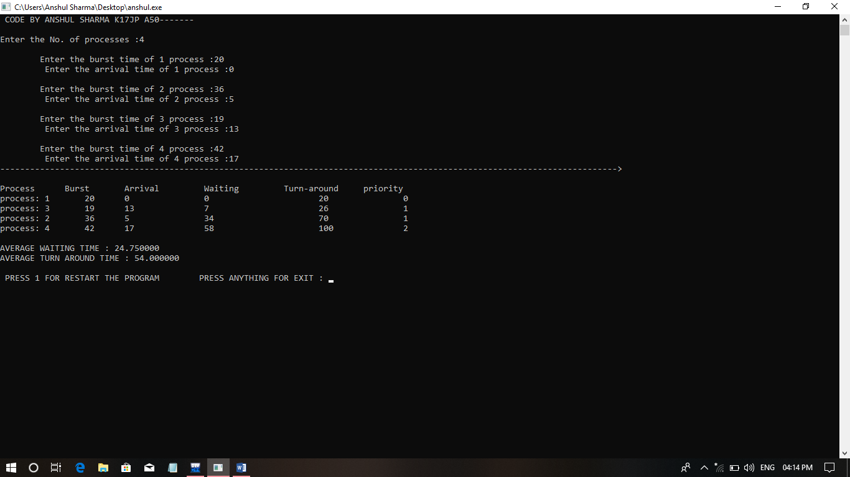

2
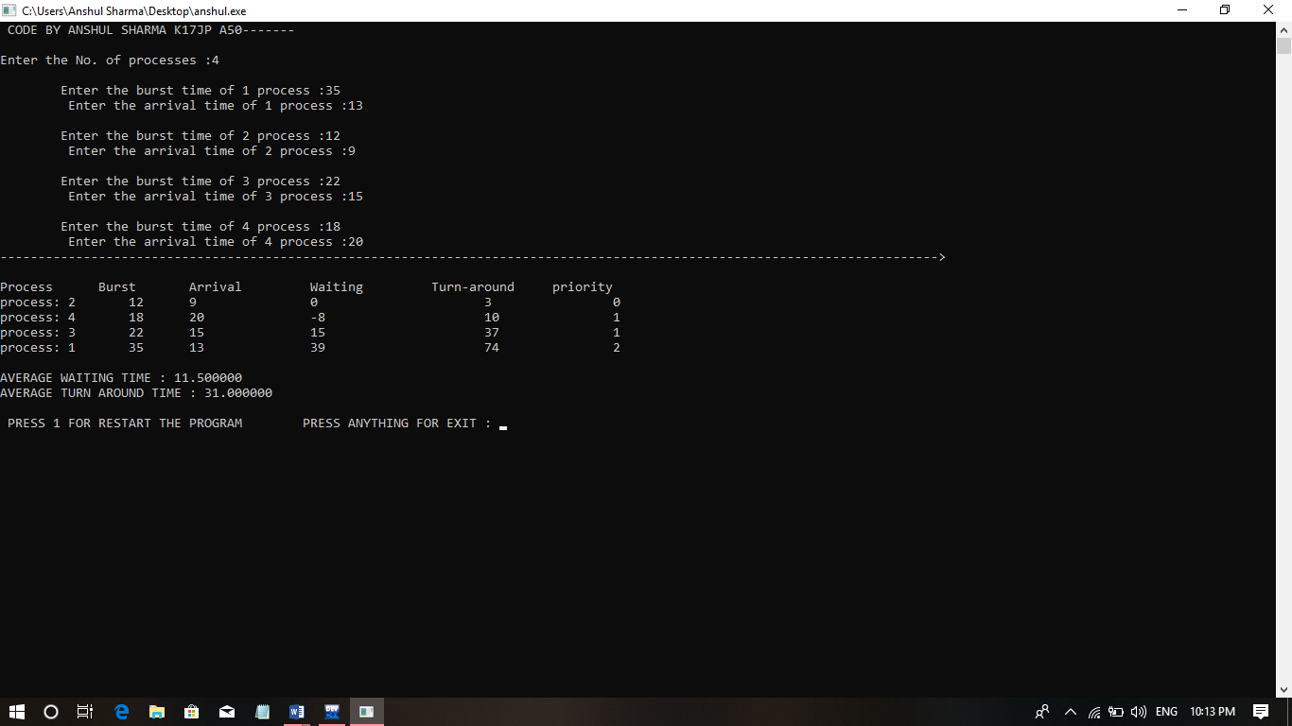

3
